ABOUT THE PRESENTERS

J. Paul Willging, MD is Professor of Otolaryngology – Head and Neck Surgery at the University of Cincinnati Medical Center. He is Director of: Clinical Operations for the Division of Pediatric Otolaryngology at Cincinnati Children’s Hospital; Interdisciplinary Feeding Team; Pediatric Otolaryngology Fellowship Training Program.

Daniel Benscoter, MD is an Associate Professor in the Division of Pediatric Pulmonary Medicine at Cincinnati Children’s and Director of the Transitional Care Center (TCC) at CCHMC. He is a member of the Aerodigestive physician team.

Khalil El-Chammas, MD is an Associate Professor in the Division of Gastroenterology, Hepatology, & Nutrition at Cincinnati Children’s. He is a GI physician on the Interdisciplinary Feeding Team.

Claire Kane Miller, PhD, MHA, CCC-SLP is the Senior Clinical Director of the Division of Speech-Language Pathology at CCHMC. Her clinical and research expertise is in the instrumental evaluation and management of feeding and swallowing issues in pediatric patients with structural and neurological deficits.

Brenda Thompson MA, CCC-SLP is the Clinical Manager of the Speech Pathology Inpatient Team at Cincinnati Children’s Hospital Medical Center. She has a special expertise in the evaluation and management of infants in the Neonatal Intensive Care Unit (NICU).

Karen Rizzo, MA, CCC-SLP is a clinical coordinator in the division of Speech-Language Pathology/Interdisciplinary Feeding Team. Her clinical expertise is in the areas of dysphagia evaluation and treatment.

Sarah Kaskie, MA, CCC-SLP is a staff speech-language pathologist participating in the Tube Weaning and FEES clinic. She has a special interest in infants and toddlers with complex feeding issues.
Tuition includes continental breakfast and lunch, course handouts, pediatric dysphagia textbook, CEUs, certificates of course attendance, and a networking reception on Day 1.

Directions to the conference rooms and hotel options will be sent with e-mail confirmation of registration.

CONFERENCE FEE

Early Registration by: September 20, 2024 | $475.00
Registration after September 20, 2024: | $500.00
Registration Deadline: October 2, 2023

ON-LINE REGISTRATION IS REQUIRED:

PAYMENT OPTIONS:

- CREDIT CARD: register online as described above. (Transactions will be processed at time of registration).
- CHECK: register online as described above, complete the form below, and submit form with payment (make checks payable to CCHMC) (address below).

Name: _________________________________________

Email: _________________________________________

Phone: _________________________________________

Cheryl Warning, Coordinator – Program Management
Division of Speech-Language Pathology, MLC 4011
Cincinnati Children’s Hospital Medical Center
3333 Burnet Avenue, Cincinnati, OH 45229-3039
Phone: (513) 636-3129 OR (800) 344-2462 Ext. 3-129
Email: Cheryl.warning@cchmc.org
Cancellation policy:
- 85% of the workshop fee will be refunded if written notification of cancellation is received more than 2 weeks prior to the workshop.
- 50% of the workshop fee will be refunded if written notification of cancellation is received less than 2 weeks prior to the workshop.
- No refund will be given if notification of cancellation is received less than 5 days before the workshop.

Hotel Block will be held at the Graduate Cincinnati Hotel, 151 Goodman Drive, Cincinnati Ohio 45219

CCHMC FEES Workshop Group Block

*Please note: the courtesy hotel block rate will expire on 9.09.24
**Transportation will be provided from the hotel to the course.
For more information about
Cincinnati Children’s Hospital
Medical Center, visit our website:
http:/www.cincinnatichildren’s.org

Pediatric Dysphagia Series:

Instrumental Evaluation of
Pediatric Dysphagia: Pediatric Flexible
Endoscopic Evaluation of
Swallowing (FEES)

October 4 & 5, 2024

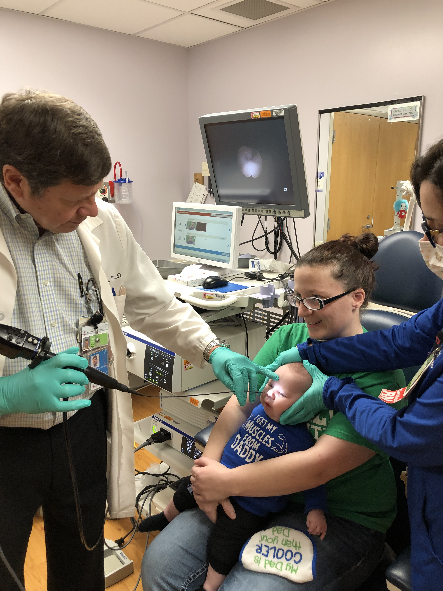
The Division of Otolaryngology-
Head and Neck Surgery
&
The Division of Speech – Language Pathology

Cincinnati Children’s Hospital Medical Center

Medical Office Building
Cincinnati Children’s Hospital
Medical Center

3430 Burnet Avenue
Medical Office Building, Rooms BE5.201-5.202
Cincinnati, OH 45229

DAY 1 Friday October 4, 2024
7:45 – 8:15 Registration in the medical office building
Breakfast
8:15 – 8:30 Welcome, Course Objectives and
Introduction of Speakers – Dr. J. Paul
Willging
8:30 – 9:00 Overview of the comprehensive Aerodigestive
Diagnostic Assessment
Dr. J. Paul Willging/CK Miller, PhD
9:00 – 9:45 Clinical Presentation and Identification of
Aspiration; Medical Management, Dan
Benscoter, MD
9:45 – 10:15 History of Pediatric
FEES, Roles on the FEES Team at
CCHMC, Claire Miller, PhD/ Jen Badinghaus, RN/J. Paul Willging, MD, Faculty
10:15 – 10:30 BREAK
10:30 – 11:00 CCHMC FEES Protocols: NICU protocol, medically fragile patients, breastfeeding protocol
11:00 – 11:30 Anatomy, Endoscopic View of Normal/Abnormal
11:30 – 12:00 Interpretation of Swallowing Dynamics
12:00 – 1:00 LUNCH (PROVIDED)
1:00 – 1:45 Updates and Considerations from the Gastroenterology Perspective
Khalil El-Chammas, MD
1:45 – 2:00 Questions/Discussion
2:00 – 2:30 Introduction to equipment logistics, tips/tricks,
break into small groups for “hands-on
activities with handling the scope and
conducting FEES procedures – J. Paul
Willging, MD
2:30 – 2:45 BREAK
2:45 – 5:00 Re-convene in Location C-2, Fees Clinic
for hands-on Practice; Passing the
Scope; Swallowing Workstation
Measures, Facility Tour to Include
Sterilization Area and Storage Area for
Equipment - Faculty
5:00 – 5:15 Questions, Answers and Adjourn
5:15 – 5:30 Break
5:30 – 6:30 Networking Reception

DAY 2 Saturday, October 5, 2024

8:00 – 8:30 Continental breakfast
8:30 – 9:30
9:30 – 10:30 Interpretation of the FEES Exam, Cases
J. Paul Willging, MD/Claire Miller, PhD/Karen Rizzo, MA, CCC-SLP & Sarah Kaskie, MA, CCC-SLP
10:30 – 10:45 BREAK
10:45 – 11:45 Role of FEES in the NICU and with
Medically Fragile Patients, Brenda Thompson, DHSc, CCC-SP
11:45 – 12:00 Questions, Answers and Review
12:00 – 1:00 LUNCH (PROVIDED)
1:00 – 2:00 Continue Case Interpretation/Comparing and Contrasting Videofluoroscopy and FEES – Faculty
2:00 – 3:00 Integration of High-Resolution Pharyngeal Manometry (HPRM) in the Pediatric FEES Clinic
J. Paul Willging, MD, Claire Miller, PhD
3:00 – 3:15 BREAK
3:15 – 4:15 Putting It All Together: Setting up a FEES
Clinic, Scope Care, Identifying a Mentor
J. Paul Willging, MD & faculty
4:15 – 4:30 Questions, Course Evaluation, Adjourn

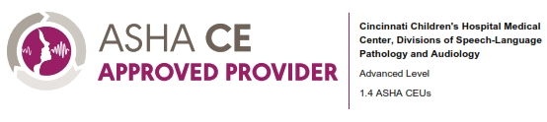

For speaker disclosure forms, please access the following link:

COURSE DESCRIPTION
The focus of this course will be upon the use of instrumentation in the assessment and management of pediatric dysphagia. Protocols for the use and interpretation of Fiberoptic Endoscopic Evaluation of Swallowing (FEES) and videofluoroscopic evaluation of swallowing (VSS) will be presented. The application of other diagnostic measures such as impedance and manometry will be presented.

LEARNER OUTCOMES

Upon completion of this seminar, the participants will be able to:

- Describe the protocols used in pediatric fiberoptic endoscopic and videofluoroscopic swallowing assessments and the application of each study in special populations such as breastfeeding infants, protocol in the neonatal intensive care unit, and other medically fragile infants and children
- Describe the equipment components needed for instrumental assessment of FEES
- Identify clinical indications for instrumental assessments of swallowing.
- Explain how to implement the use of pediatric FEES in the clinical setting
- Discuss the effects of chronic aspiration on overall pulmonary status.
- Differentiate advantages and disadvantages associated with instrumental assessments of swallowing.
- Discuss the range of instrumental assessments available for evaluation of pediatric dysphagia.
- Identify normal and abnormal swallowing dynamics viewed endoscopically
- Describe available methodology for assessment of aspiration.
- Recognize and identify anatomical landmarks and key structures in the upper aerodigestive tract.

